Template for drafting an AI use case
AI-driven environmental KB (Knowledge Base)
1. Main area
Select the area to which the use case primarily belongs:
- ☐ Strategy, Governance and Organisation
- ☐ People, Skills and Ways of Working
- ☐ Data, Technologies and Infrastructure
- þ AI Applications and Value Creation

2. Challenge or opportunity
Describe the problem, need or opportunity that the use case addresses.
The environmental sector is characterized by an unprecedented proliferation of data and information. Over the past decade, governments, intergovernmental organizations, research institutes, regulatory bodies, and industry players have collectively produced a vast and ever-growing body of publications, reports, technical notes, legislative texts, scientific studies, and policy documents.
While this wealth of information is, in principle, an asset, it gives rise to several major operational challenges:
- It has become increasingly difficult and time-consuming to locate accurate, contextually relevant, and properly sourced information amidst millions of documents.
- Alongside reliable information, a significant volume of unverified or erroneous content is in circulation.
Consequently, using standard search engines or consumer-grade AI tools does not always yield verified and reliable information.

3. Proposed use of AI
Explain how AI could help address the challenge.
There is an abundance of reliable information produced by trusted entities, and these resources can be pooled. Rather than relying on a general-purpose large language model (LLM) trained on the open internet, this use case proposes creating a specialized knowledge base (KB) populated exclusively with content from selected trusted entities—such as government agencies, intergovernmental organizations, accredited research laboratories, regulatory bodies, and other duly validated institutional publishers.
Developing a document database populated exclusively by reliable sources would facilitate the use of environmental information resources.

4. Scope
Define what is included in the use case and set its boundaries.
The scope encompasses data, documents, online publications, and information from reliable sources, offering the following potential capabilities:
- natural language question-answering with source citation
- document and corpus search (keyword-based and semantic)
- document summarization (single document or corpus)
- writing assistance (generation of notes as drafts)
Covered topics could include the environment, energy, transport, climate and housing.
Users could be staff members as well as partners.
For more reliable and accuracy responses, the KB could be divided in different document collections to improve retrieval precision and reduce cross-topic noise.

5. Expected outcome
Describe the concrete result that the use case is expected to deliver.
An AI-powered conversational agent will answer questions based solely on reliable sources, specifying exactly which source is used for each answer.
Searching for documents and information will become faster and more reliable.
Summarizing documents or sets of information will also be made easier.
The solution relies on a trusted document base designed to be enriched over time, thereby offering the potential for increasingly diverse applications.

6. Contribution to the environment and digital agenda
Explain how the use case supports both environmental objectives and digital development.
Environmental agenda
By making verified environmental data immediately accessible, the knowledge base enables decision-makers to assess the situation in specific sectors or regions more quickly and accurately.
In an environment where many unverified claims circulate, the ability to provide rapid, well-sourced, and fact-checked answers strengthens the capacity to counter misinformation with authoritative evidence.
The citation and traceability mechanism ensures that any environmental claim can be verified against its original source, thereby reinforcing the information's credibility.
Digital agenda
The knowledge base is owned and controlled in-house, and its data ingestion is governed by defined quality standards, avoiding any reliance on third-party AI services.
The architecture is modular and scalable: new thematic collections, trusted sources, and user groups can be added incrementally without the need to overhaul the core system.

7. Key conditions and considerations
Identify the most important requirements, dependencies or risks.
The technical architecture is based on a RAG (Retrieval-Augmented Generation) approach.
The tool requires no specialized skills. It is an internal support tool populated by trusted contributors, intended solely for use by staff and partners. The content (corpus, Q&A) is not meant for direct external dissemination but may be used to draft specific communications.
Although the knowledge base is populated exclusively from reliable sources, the primary challenge lies in the risk of errors ("hallucinations") or inaccuracies (such as the omission of available information) in the responses generated by the LLM. Consequently, monitoring results (involving automated checks potentially supplemented by optional human validation) and rejecting certain responses, could be considered as complementary measures.

Typical technical infrastructure and integrations:
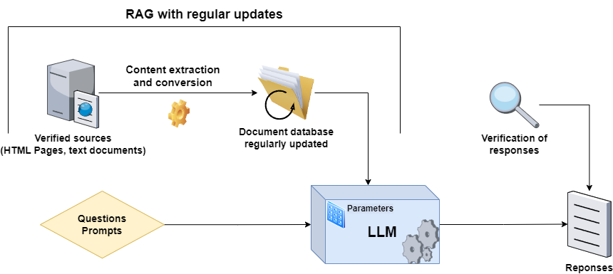

Some solutions are already experimented in the French Ministry of Ecological Transition.

